**Online Health Appointments Information Leaflet**

**What is an online health appointment?**

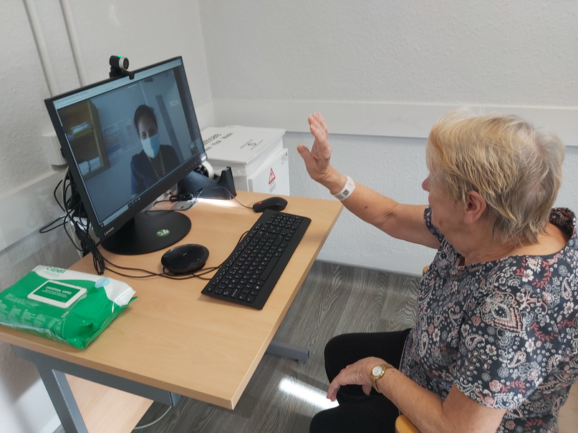

An online appointment allows you to talk to your healthcare professional using video technology on the internet from a computer, tablet or smartphone

Online appointments are offered, if suitable, by many hospital and community services in the HSE

**This type of appointment might not be suitable for certain conditions or patients.**

**(For example, if your healthcare professional needs to listen to your breathing or look in your ears)**

**Benefits**

* online appointments are safe and secure
* informed consent must be given before the call
* the call will not be recorded without your permission
* improves access
* less travel
* less cost
* more convenient

**Your privacy**

**Practical tips to help with your call**



* Use a fully charged device
* Choose a brightly lit part of the room
* Make eye contact
* Speak in your normal voice

**Helpful information**

* If you have technical issues during your online appointment, your healthcare professional will understand and support you
* At the start of your online appointment, your healthcare professional will ask you if you are happy to proceed with the online call
* You may request a phone call or face-to-face appointment at any time

**If you do not understand how an online appointment will work for you after talking to your healthcare professional and reading this leaflet, please talk to your healthcare professional again for more information**



www2.hse.ie/services/online-health