How do I know if I’m on the national HealthIrl domain or not?

You can click on the dark red ‘Who am I’ icon on your desktop and check the ‘domain’ at the top of information shown, as below ‘healthirl.net’. The person in the below example is on the Healthirl domain and so can get a Teams licence.

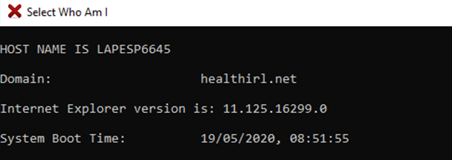

Alternatively, you can enter ‘domain’ into the search bar on the bottom left of your screen, and check the information shown, as below. Again, this person is on the healthirl domain.

If I’m not on the HealthIrl domain can I still access Teams meetings?
Yes- if you are invited to a Teams meeting, you can attend by simply clicking on the invitation link. If the organiser of the meeting designates you as a ‘presenter’ in the Meeting Options, you will also be able to share your screen and present to fellow attendees.

